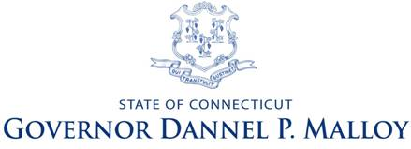
Governor’s Cabinet on Nonprofit Health and Human Services

CABINET MEETING
Wednesday, October 30, 2013
9:00 – 11:00 - LOB room 1B

THE CABINET WILL BE VOTING ON ITS FINAL REPORT

AGENDA

- Welcome (Edelstein)
- Approval of minutes of 9/27/13 Cabinet Meeting – ACTION ITEM
Work Group Reports – Recommendations and Discussion

- Work Group on Contract Procurement and Administration

Cost Standards
ACTION ITEM
- Work Group on Jobs

Final Recommendations on Goal 3 (follow up from 9/27/13 Cabinet meeting)
ACTION ITEM

- Consideration of Draft Report to the Governor (DeBiasi)
ACTION ITEM

- Announcements and other business (Edelstein)

- Adjournment (DeBiasi)

