New Design V1
PROD sites:
- https://portal.ct.gov/careerconnect
- https://portal.ct.gov/communityinvestmentfund
- https://portal.ct.gov/heatinghelp
- https://portal.ct.gov/sdecertification
- https://portal.ct.gov/summerstemchallenge
- https://portal.ct.gov/hatecrimes

Instructions: Complete the tasks for each component and/or page listed below.
Task 1: Verify external sites (non-ct.gov URL) displays external link icon following link.
Task 2: Verify icon takes on same color and behavior as the link.
Task 2: Verify any dk grey text (#333) now displays black (#000)

Agency Alert
- https://portal.ct.gov/heatinghelp
- NOTE: PROD does not contain an external link to test
Internal link - Active: Font color: blue (#09538B), Icon color: blue (#1F64E5)
Decoration: Underline
External link - Active: Font color: blue (#1F64E5), Icon color: blue (#1F64E5)
Decoration: Underline
Body text - Font color: black (#000)
Internal link - On-Focus: Font color: dk blue (#00214D)
Decoration: Underline
External link - On-Focus: Font color: dk blue (#00214D), Icon color: dk blue (#00214D)
Decoration: Underline

Navigation

Primary Navigation
- https://portal.ct.gov/hatecrimes
- https://portal.ct.gov/communityinvestmentfund

Active: Font color: white (#FFF), Icon color: white (#FFF)
Decoration: None
On-Focus: Font color: blue (#87BEE3), Icon color: blue (#87BEE3)
Decoration: None

Secondary Navigation
- https://portal.ct.gov/sdecertification
- https://portal.ct.gov/summerstemchallenge
- NOTE: PROD does not contain an external link to test
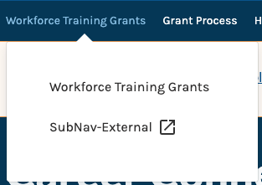
Active: Font color: dk grey (#2D2C2C), Icon color: dk grey (#2D2C2C)
Decoration: None
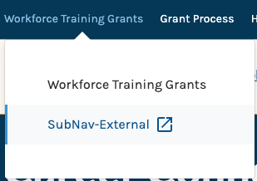
On-Focus: Font color: dk blue (#09538B), Icon color: dk blue (#09538B)
Decoration: None
Background color: lt blue (#F7F9FA)

Components

Featured Content Card
- https://portal.ct.gov/heatinghelp
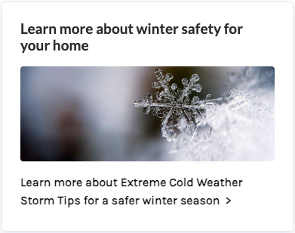
Active: Text font color: black (#000), Title color: dk grey (#2D2C2C)
Decoration: None
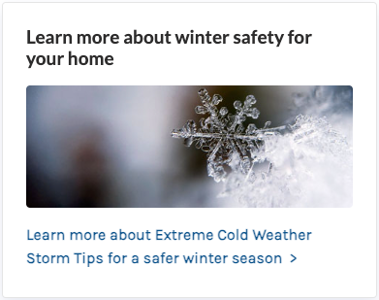
On-Focus: Text font color, Title color: dk blue (#09538B)
Decoration: None
Notes:
- Chevron displaying was manually added in the Rich Text field.
- Entire card is on-focus

Story Card
- https://portal.ct.gov/heatinghelp/your-health
- NOTE: PROD does not contain Featured Story to test. V1 sites are using Lead Story variant

Text color: black (#000) / Title color: dk blue (#2D2C2C)
Active: Font color: white (#FFF), Icon color: white (#FFF)
Decoration: None

On-focus: Same

Tile Card
- https://portal.ct.gov/sdecertification/epps---educator-preparation-providers
- https://portal.ct.gov/sdecertification/certified-educators
- https://portal.ct.gov/careerconnect
- NOTE: PROD does not contain Tile Card- Original variant to test. V1 sites are using New or Icon variants
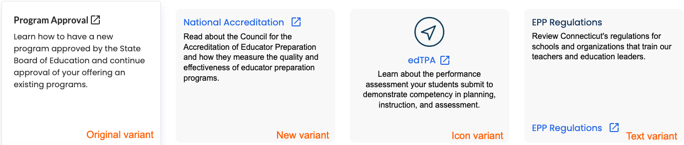
Original variant: Text color: dk grey (#2D2C2C) / Title color: dk grey (#2D2C2C)
Other variants: Text color: black (#000) / Title color: dk blue (#00214D)
Active: Font color: blue (#1F64E5), Icon color: blue (#1F64E5)
Decoration: None
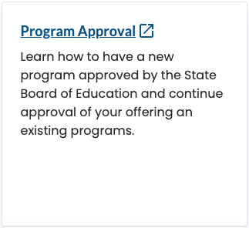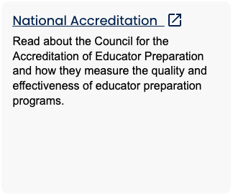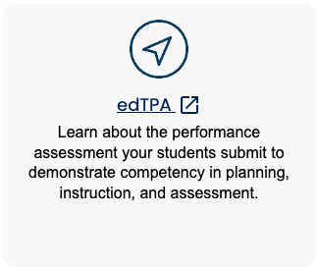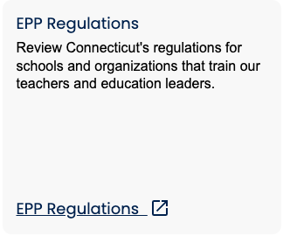
Original variant On-Focus: Font color: dk blue (#09538B), Icon color: dk blue (#09538B)
Other variants On-Focus: Font color: dk blue (#00214D), Icon color: dk blue (#00214D)
Decoration: None

Vertical Cards Banner
NOTE: PROD does not contain component to test.
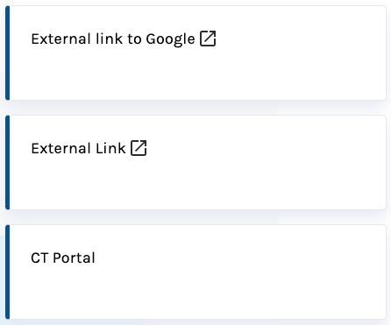
Active: Font color: black (#000), Icon color: black (#000)
Decoration: None
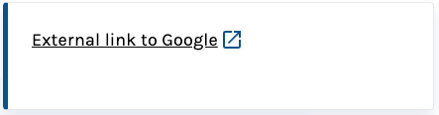
On-Focus: Font color: dk blue (#09538B), Icon color: dk blue (#09538B)
Decoration: Underlined

Grid Banner Home
- NOTE: PROD does not contain component to test.
- Note: Each card has entire card as on-focus
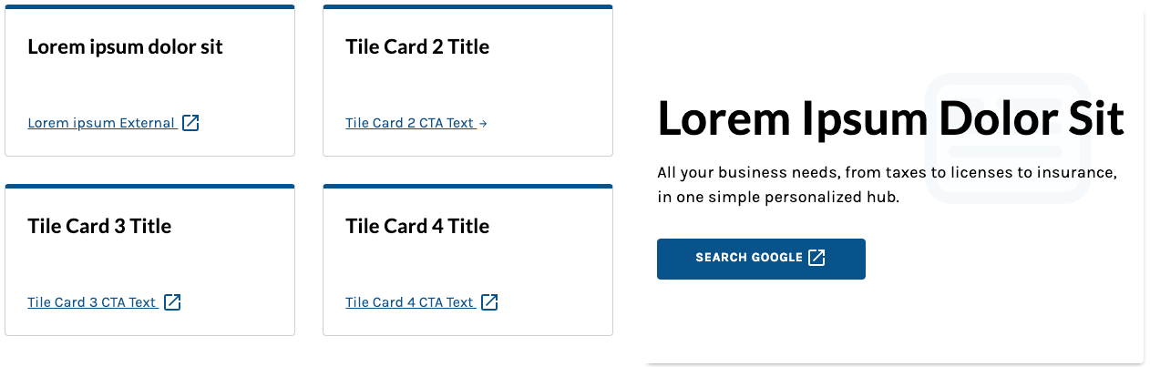
Text color: black (#000) / Title color: black (#000)
Active: Font color: dk blue (#09538B), Icon color: dk blue (#09538B)
Decoration: Underline
On-Focus: No change

Tile Card Compound
- https://portal.ct.gov/careerconnect
- NOTE: PROD does not contain component to test.
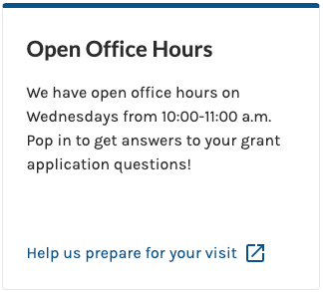
Text color: dk grey (#2D2C2C) / Title color: dk grey (#2D2C2C)
Active: Font color: dk blue (#09538B), Icon color: dk blue (#09538B)
Decoration: None
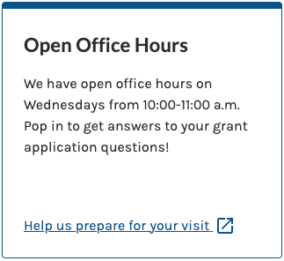
On-Focus: Font color: dk blue (#09538B), Icon color: dk blue (#09538B)
Decoration: Underlined

Rich Text Editor
- https://portal.ct.gov/heatinghelp/energy-efficient-solutions
- https://portal.ct.gov/heatinghelp/offering-help
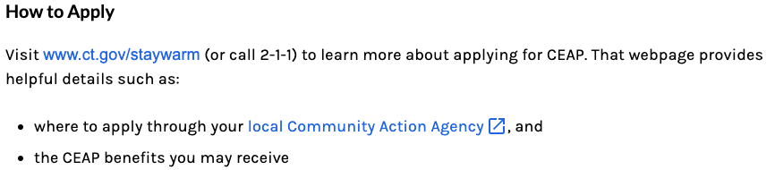
- https://portal.ct.gov/communityinvestmentfund/home/cif-board
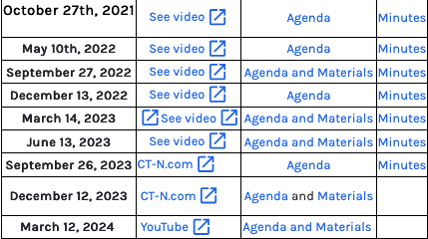
Text color: black (#000) / Title color: black (#000)
Active: Font color: blue (#1F64E5), Icon color: blue (#1F64E5)
Decoration: None
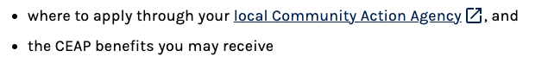
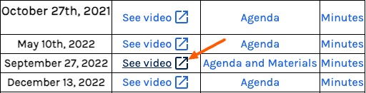
On-Focus: Font color: dk blue (#09538B), Icon color: dk blue (#09538B)
Decoration: Underlined

Featured Content Card
- https://portal.ct.gov/communityinvestmentfund
- https://portal.ct.gov/hatecrimes
- https://portal-staging.ct.gov/sdecertification

Text color: black (#000) / Title color: black (#000)
Active: Button color: white (#09538B)
Active: Button Font color: white (#FFF), Icon color: white (#FFF)
Decoration: None

On-Focus: Button color: dk blue (#053756)
Font color: white (#FFF), Icon color: white (#FFF)
Decoration: None

Quick Links
- https://portal.ct.gov/heatinghelp/why-heating-help

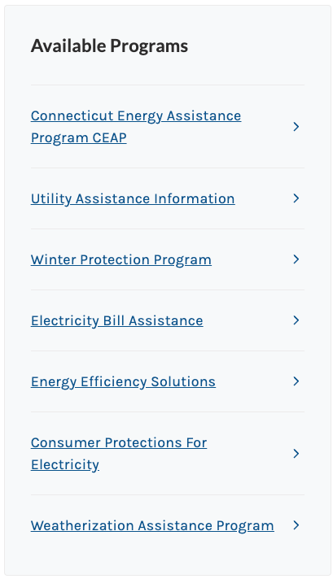
Title color: black (#000)
Active: Font color: blue (#1F64E5), Icon color: blue (#1F64E5)
Decoration: Underline
On-Focus: No change

EXEMPT Items

Imagery

Icons (Logos/Images)
- No icon

Icons (KB Share SM)
- https://portal.ct.gov/heatinghelp/knowledge-base/articles/the-connecticut-energy-assistance-program-ceap
- https://portal.ct.gov/sdecertification/knowledge-base/articles/coaches/how-do-i-renew-my-coaching-permit
- No icon



